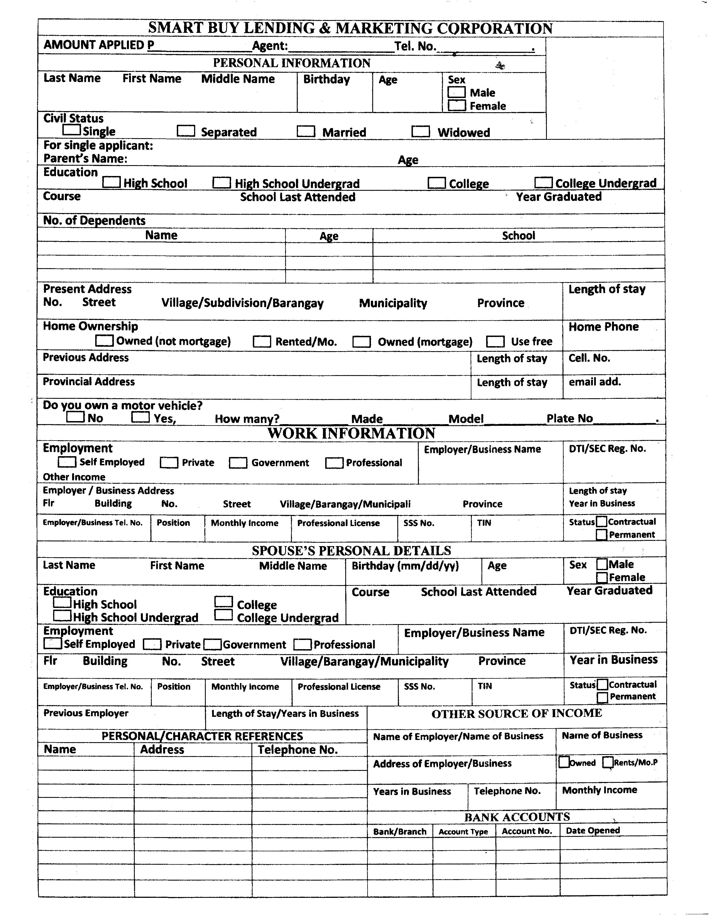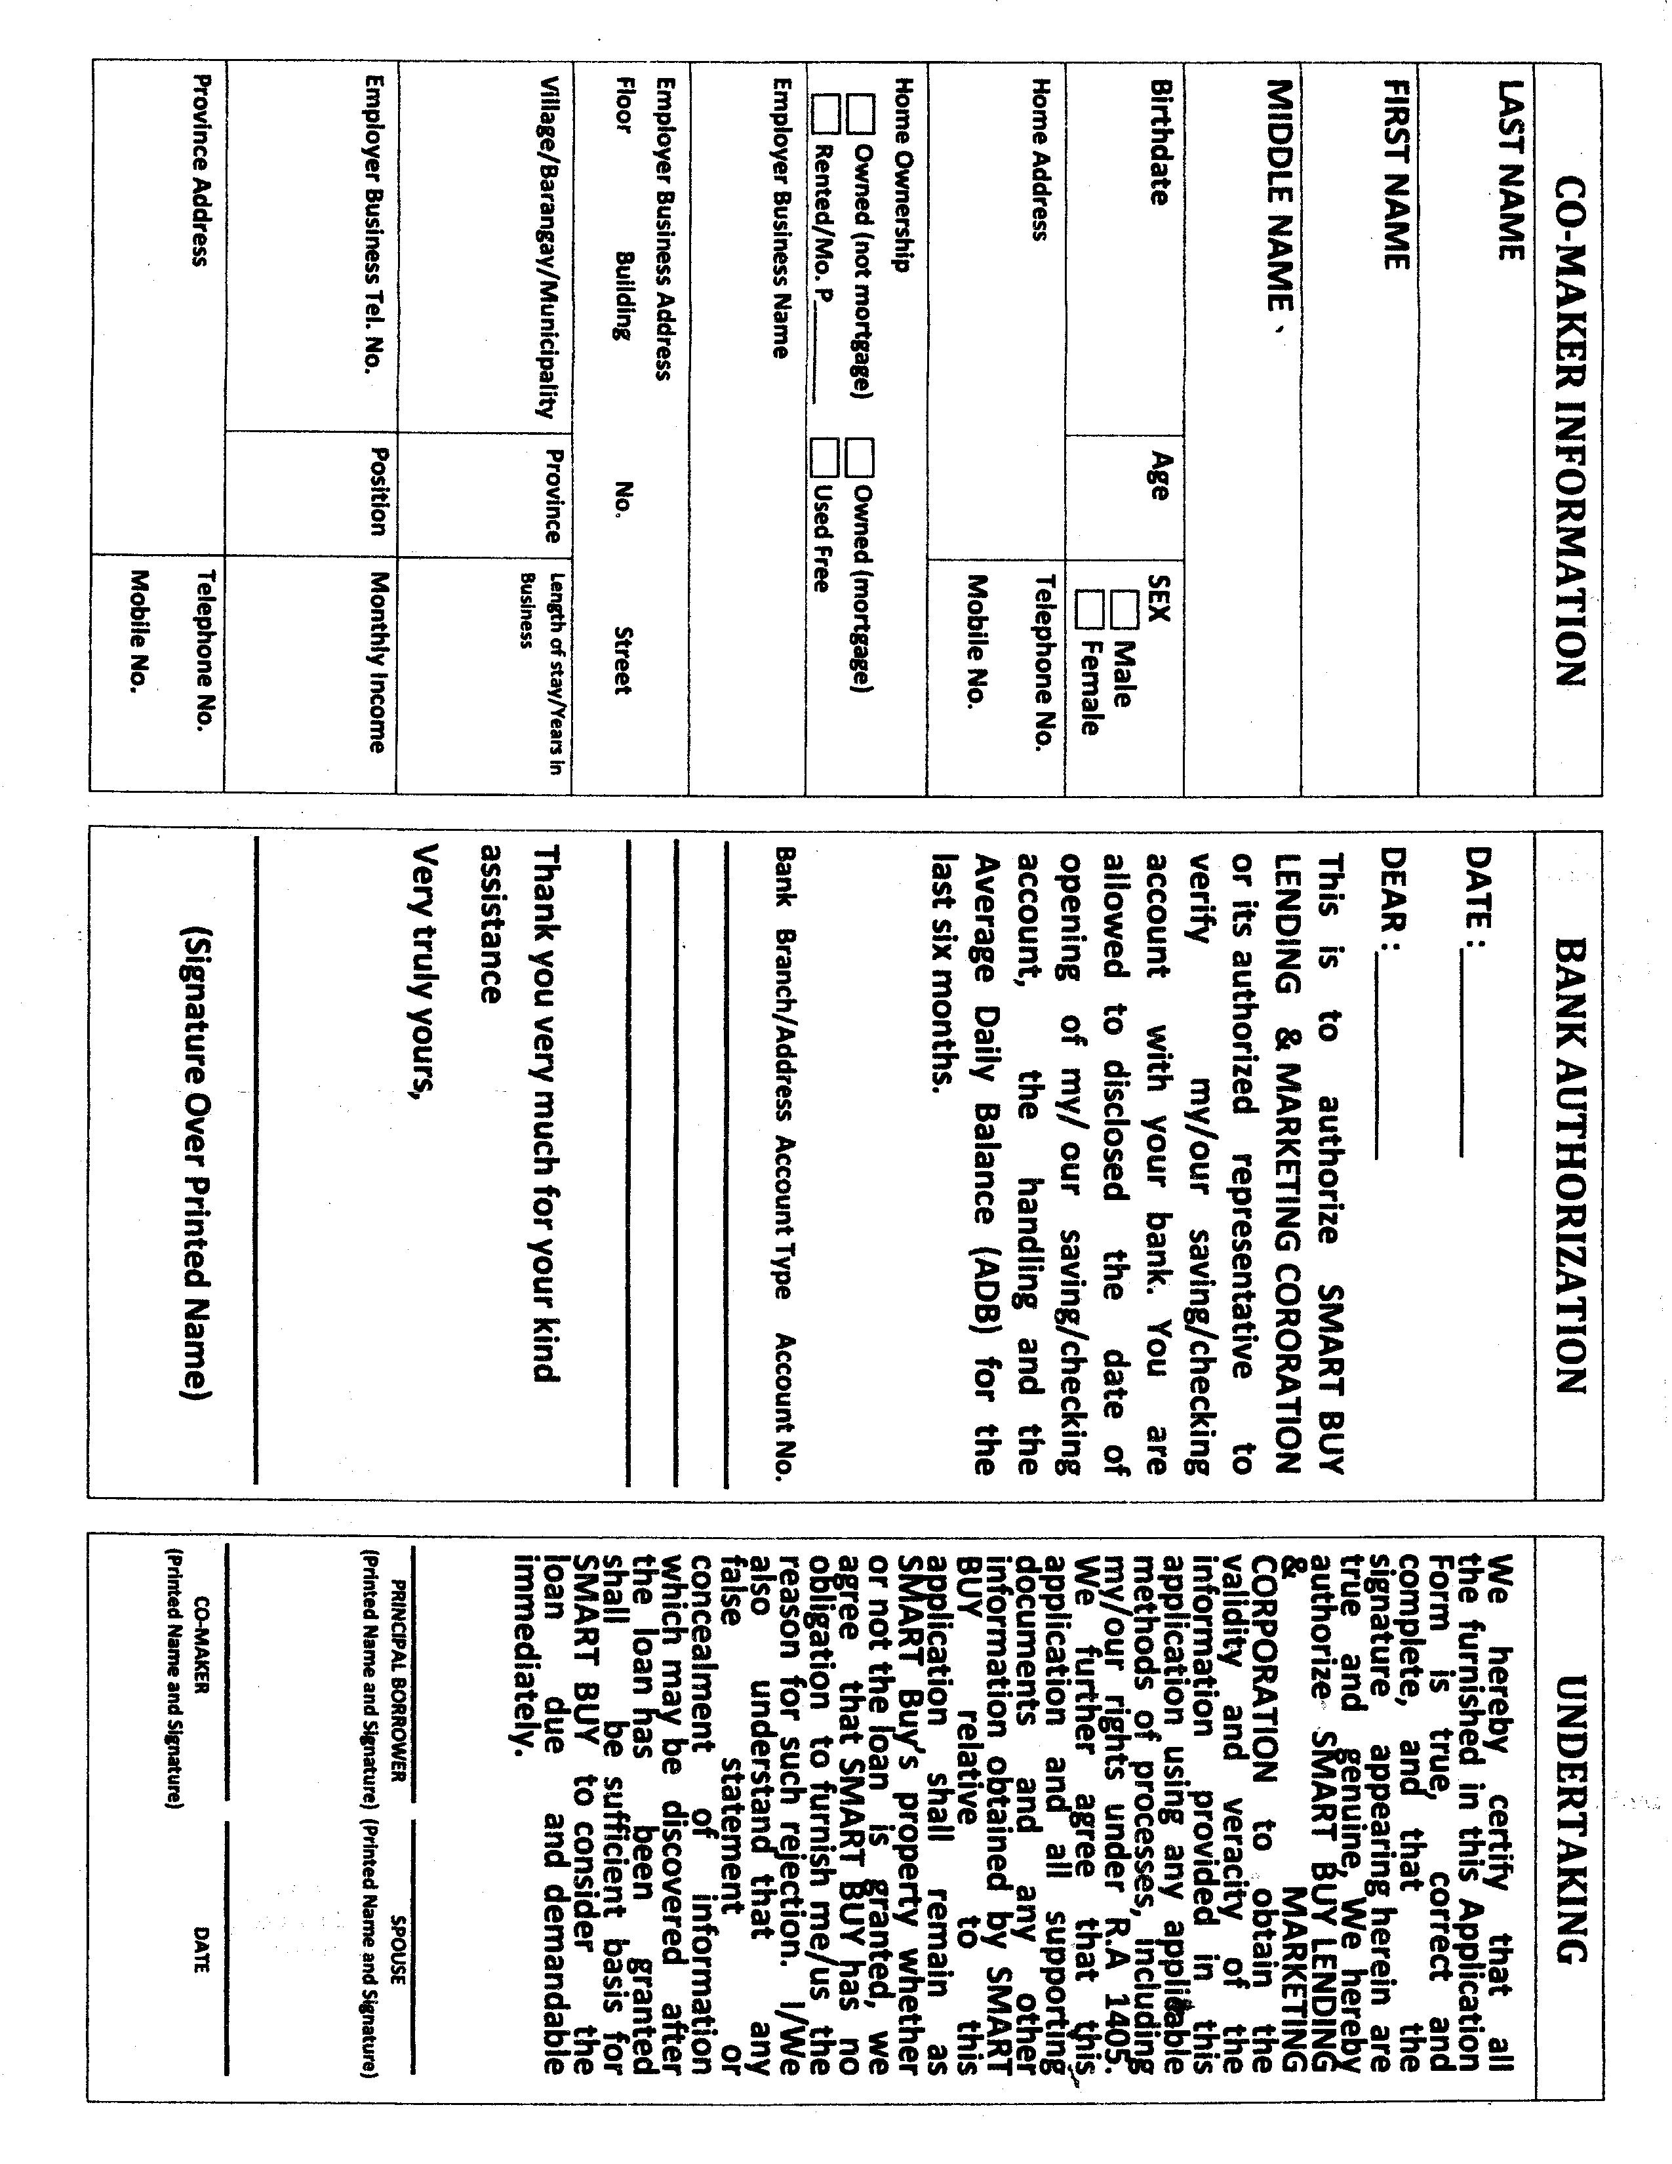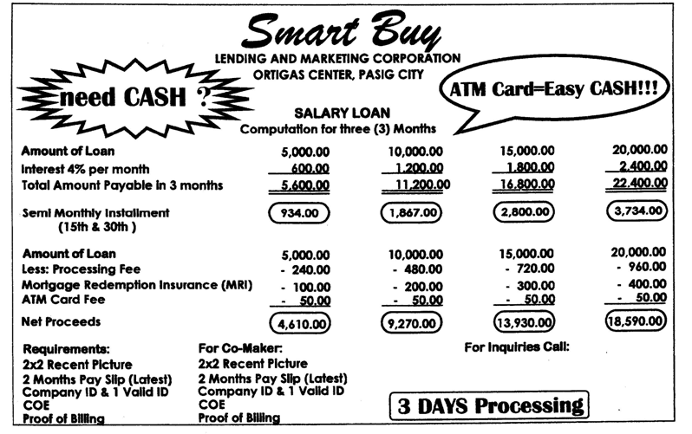
REQUIREMENTS FOR BUSINESS LOAN
CHECKING ACCOUNT:
* BUSINESS PERMIT
* DTI (for single proprietorship) SEC REGISTRATION/SEC CERT. (for corporation)
* ITR (IF AVAILABLE)
* PROOF OF BILLING (ELECTRIC, WATER, TELEPHONE BILL
* BARANGAY CLEARANCE
* CEDULA
* 2X2 ID PICTURE
* 2 VALID ID'S
* 3 MONTH BANK STATEMENT W/ USED CHECKS
* BUSINESS PICTURE (optional)
* BANK CERTIFICATE
NOTE: Pls. print this form in 8.5"x13" sized bond paper

NOTE :
***ATM LOAN AND BUSINESS LOAN MUST HAVE CO-MAKER
AND IT SHOULD BE BACK TO BACK
***LOANABLE AMOUNT WHICHEVER IS LOWER EQUAL AMOUNT
RELEASED BACK TO BACK

